Submitted by:

Ananya Chakraborty Gourab

Course ID: CSE403

Course Name: Networking Management

Section:01

Case Study: Optical Network: Control and Management

Submission Date: 28.04.24

Abstract:

Although major telecom operators have been using dense wavelength division multiplexing technology in their networks for more than ten years, the capabilities of its   
  
Comparing networking to its packet-switched equivalents in upper layer networks and digital cross-connect systems, network control and administration have not kept up. We clarified the situation by looking at the optical layer's existing architecture, how it interacts with other network technological layers, and the ways that network administration and control are now implemented. We shed more light on this by describing how the evolution of the optical layer has been influenced by a blend of technical and business viewpoints. We investigate future initiatives to bridge this gap as we wrap up.

Introduction:

Since the term "optical network management and control" encompasses a wide range of topics in the telecommunications sector, our first goal is to precisely define the scope of this article. Initially, the term "optical" is often used in a fairly broad sense. One common interpretation, for instance, is to refer to any device having an optical link as "optical equipment." This more inclusive definition would cover a wide range of devices that facilitate cross-connection via electrical means, like SONET/SDH DCSs. In fact, almost all telecommunications equipment can support optical interfaces these days due to the quick development of tiny form optics. Therefore, we will limit our discussion in this paper to DWDM hardware and the fiber network that supports it, in a more precisely defined optical layer. We clarify this more precisely later.

Second, a wide range of organizations, including standards organizations, forums, research collaborations, conferences, journals, and periodicals, address network management and control.   
  
Each telecommunications carrier, or carrier for short, will select its own network management and control approach based on its unique needs. Large network carriers will not solely rely on the optical network management options provided in these bodies.   
Therefore, we concentrate on a realistic scenario in which the optical layer is structured and operated in today's huge telecommunications carriers, rather than venturing into these considerably broader regions. But in the final sections, we quickly address the possible long-term effects of important norms and concepts. Two ideas are essential in this context: restoration and network stacking. The optical layer in big telecom carriers is subservient to its higher layer networks. For instance, interconnections of upper layer (overlay) networks account for almost all of the demand for optical-layer connections. The interdependence of the layers' interaction is largely dependent on which layers offer healing.

We have included historical viewpoints on the evolution of the optical layer to its current configuration to help with this knowledge. Possibly the most significant part of our discussion is the business context, which is necessary to explain the priorities and trade-offs that resulted in the current network management and control systems.   
After outlining the optical layer's current condition, we will move on to talk about R&D efforts for the layer's future development as well as network control and management.

Background information on the environment in which the optical layer functions is given in Section II. The evolution and structure of the current optical layer are covered in Section III. The management and control of modern networks is covered in Section IV.   
The evolution of the optical layer is examined in Section V, along with our analysis of the most likely course of progression.

1. Network segment and Layer:

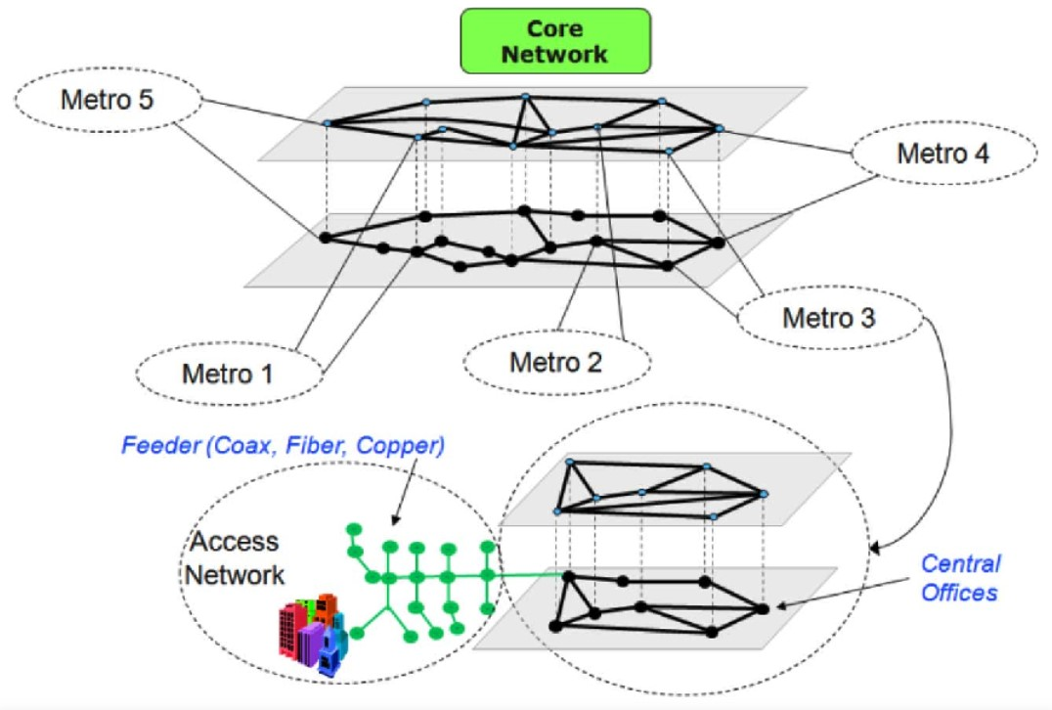

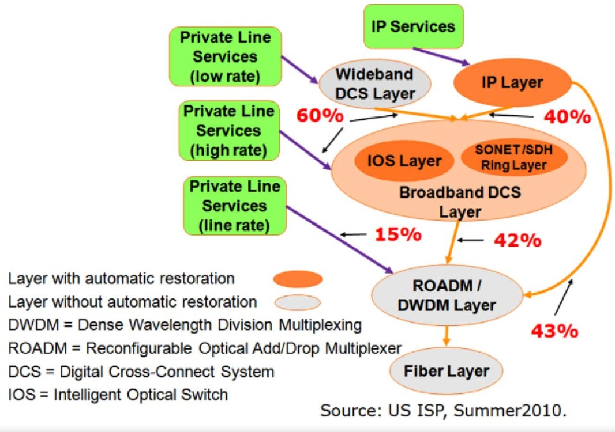

1. Network Segments

Fig. 1 illustrates how we conceptually segment a large

national terrestrial network.

Large telecommunications carriers are organized into metropolitan (metro) areas and most of their equipment is housed in structures known as COs. Nowadays, optical fiber connects almost every CO. The section of the network that lies between a customer location and its first (serving) CO is known as the access segment. Be aware that another carrier may be included in the phrase "customer." Metro segments are connected by the core section.   
Networks can be further categorized into layers called links and nodes, which are the logical adjacencies between the equipment and switching or cross-connecting equipment, respectively. These layers can be represented graphically as network graphs layered vertically on top of one another. Higher layer network links (capacity) are made available to lower layer networks as point-to-point demands (also referred to as traffic, connections, or circuits, depending on the layer). For further information regarding the networking and business context of this

Segmentation.

1. Network Layers: Figure 2 (taken from [16]) shows the central   
     
   tiers of a major carrier's network. It is made up of two main categories of essential services: IP (Internet Protocol, or simply IP) and   
     
   personal phone. Private line services are delivered through three distinct circuit-switched layers, whilst IP services are supplied by the IP layer (usually routers): 1) a low rate private line service layer (W-DCS layer; 1.5 Mb/s); 2) an intermediate rate private line service layer (B-DCS layer; 45–622 Mb/s); this layer is made up of the SONET ring layer and/or the IOS layer (intelligent broadband DCS layer); and 3) the ROADM layer for high rate private line services (usually 2.5 Gb/s and up).   
   We are unable to fully characterize these layers and technologies in space. Utilizing the optical layer is difficult as practically Its circuits all carry higher layer network links.   
   Many of these higher layer networks in big carriers are owned by the carrier (internal to it), as Fig. 2 illustrates.   
   Additionally, the highest rate (line rate) private line services that route straight onto the optical layer typically originate from major commercial clients or links of other carriers' packet networks that are transported by circuits (private lines) that they lease. For instance, RENs, or several small regional carriers, lease private lines to connect their switches and computers. RENs are typically supported by the government or academic institutions. One important lesson is that the majority of the administration and control of the optical network is determined by the design features of packet networks.

Utilizing the optical layer is difficult as practically As previously stated, a lot of people in the sector pick up the apparatus that makes up the upper layer's nodes   
networks of Fig. 2 (such DCSs) into a more comprehensive description of optical apparatus. We don't try to cover the net-   
  
This study discusses work management and control for all these various kinds of equipment. Rather, we define the optical layer to encompass both the fiber layer that serves as their path and the more recent ROADMs as well as the older point-to-point DWDM systems. The ability to concentrate technology now allows many suppliers to combine these many technological layers into various plug-in slots of the same Bbox [for example, a DWDM optical transponder on a platform for routers). While we might discuss each of these combinations, we will limit the above definition to independent optical-layer devices to keep things simple. Additionally, the focus of our discussion is the network's core segment; the metro portion will be briefly discussed later.

III. EVOLUTION AND STRUCTURE OF

TODAY’S OPTICAL LAYER

Early DWDM Equipment: In the middle of the 1990s, DWDM equipment was first used in core carrier networks to relieve fiber exhaust. Researchers at Bell Labs pioneered a lot of this work (see, for example, [25]). Prior to primarily supporting SONET and SDH, the earliest DWDM equipment was installed with optical transponders, sometimes known as transponders, to enable a few pre-SONET interfaces. The initial DWDM apparatus was set up in linear or point-to-point arrangements.   
In other words, client signals use a normal intraoffice wave-length of 1.3 πm to enter the transponder at a DWDM terminal, say site A.The process of regenerating an optical signal involves detecting it, converting it to an electronic form, and then emitting it using a laser at a fixed wavelength determined by a channel grid (typically in the 1.55 μm range). Next, it is multiplexed with other signals at different wavelengths using a type of wavelength grating to create a multiwavelength signal that is transmitted over an optical fiber. In order to convey the multiplexed signal as far as feasible while maintaining the required level of signal quality for each constituent channel, terminal and intermediate optical amplifiers are utilized. The procedure is reversed at a corresponding DWDM terminal at the far end (position Z), where the line signal is ultimately demultiplexed into its component channels and signals. Each channel's incoming (demultiplexed) signal at position Z is first received by the transponder that corresponds with it before being sent to the client interface at the intraoffice.   
  
wavelength. In the opposite direction of transmission (from Z to A), a comparable set of tools and procedure are used.   
Two-way signals in carrier-based networks are often arranged into adjacent ports on an interface card. Each signal that enters the DWDM terminal at A and Z undergoes simultaneous multiplexing or demultiplexing. These early point-to-point networks lacked an intermediate add/drop feature, supported 4–16 wavelengths per fiber, and occasionally had their shelves set up in accordance with the protection and service interfaces of SONET/SDH rings or linear systems. In core networks that employ mesh restoration, these DWDM systems' service and protection halves often to be used in a standalone mode.

B. Reconfigurable Optical Add/Drop

Multiplexer (ROADM)

These days, outdated point-to-point DWDM systems continue   
older circuits, particularly lower rate circuits, and are occasionally utilized for sections of new circuit orders. Still,   
  
Nowadays, the majority of big carriers use ROADMs to enhance their optical layer. Unlike a point-to-point DWDM system, a ROADM has the ability to link several fiber directions, or degrees. This has prompted the creation of transponders that can be tuned more freely (sometimes referred to as no directional or steerable transponders) and the capacity to carry out an optical cross connect with remote control. If the constituent signals from two distinct fiber directions have the same wavelength, a ROADM can cross link them optically (i.e., without electrical conversion) without entirely demultiplexing the aggregate signal. A transit or through cross connection is what this is known as. Alternatively, it can establish what is known as an add/drop cross connection, which is a cross connection that goes from a fiber direction to an end transponder. Every vendor of ROADMs offers an EMS that facilitates communication with several ROADMs as well as a CLI for interacting with a single ROADM. It is through these network management and control systems that employees are able to carry out optical cross connections. Because ROADMs may cross connect wavelengths remotely, they start to include connection management features that are more similar to DCS equipment in upper layer networks.

1. Provisioning in Today’s Optical Layer:

Understanding the current optical circuit provisioning procedure in big carrier networks is useful before we talk about the management and control of optical-layer networks.   
In the optical layer, the circuit provisioning process combines automated and human procedures, but in upper layer networks it is more highly automated. We provide some preliminary information first. Fiber patch cords are used to connect devices within a single CO via fiber; these cords are arranged according to an optical patch panel. For instance, installation staff typically fibers a high-speed card or plug-in to ports on the patch panel when installing it in an IP-layer router. When installing a ROADM transponder, they follow a similar process. Prior to wAn order to cross-connect the router ports to the transponder's (client) ports is sometimes given during the circuit provisioning process. This request may be fulfilled by the same staff members manually fibering jumpers between the relevant ports on the patch panel. We observe that one kind of automated patch panel is available. It we refer to as an FXC. Refer to [14]. When an FXC is deployed, installation staff still needs to link the transponder ports and client equipment to the FXC; however, the FXC can cross-connect its ports remotely after the provisioning order is issued. Since there aren't many FXCs in use at major carriers these days, we'll assume for the purposes of this piece that the patch panel is in the lead, but we'll come back to the FXC in the final section.   
In the core section, we categorize the provisioning steps into four major groups. A circuit order may frequently call for steps from each of the four types.

1) Manual: After visiting the CO, installation staff install the plug-ins and cards and connect them to the patch panel via fiber.   
2) Manual: installation staff goes to the CO and uses the patch panel to cross-connect ports.   
3) Semiautomated: Using an EMS or CLI, provisioners ask for optical cross-connects.   
4) Completely automated: a network planner or other planning tool feeds a circuit path to an OSS.

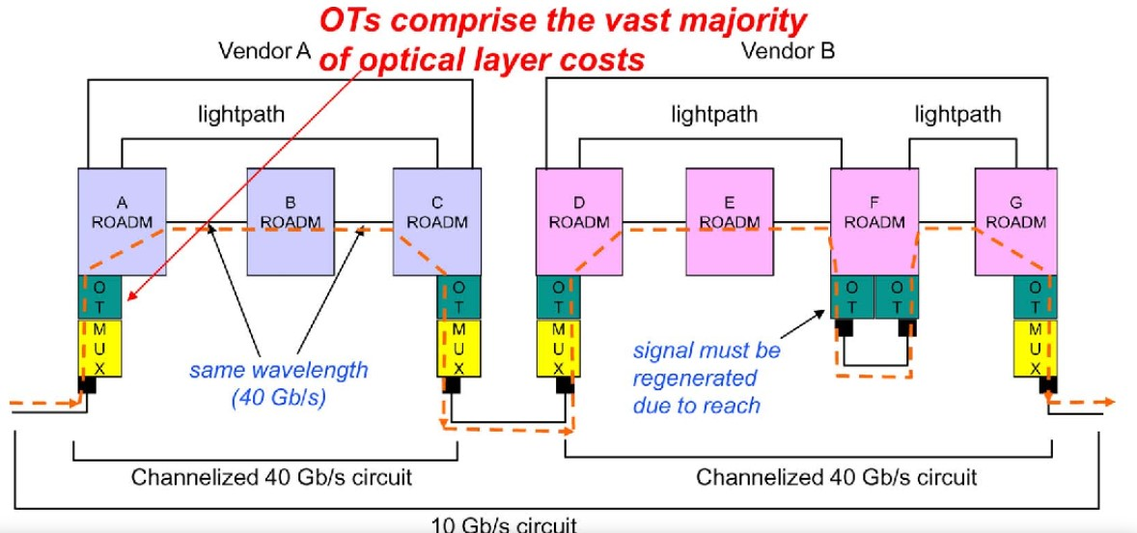

Within the optical layer of Fig. 2, a 10-Gb/s circuit is supplied between ROADMs A-G in a realistic example shown in Fig. 3. This circuit could, for instance, carry a higher layer link between two routers at ROADMs A and G that produce the client signals. In this example, there are two vendor subnetworks. A vendor subnetwork is defined as the topology of the vendor ROADMs (nodes) from a certain equipment vendor plus the links (fibers) that connect them. A domain is another term for this in several standards bodies. An optically cross-connected DWDM channel path, or one without an intermediary optical–electrical–optical (OEO) conversion, is called a lightpath. A circuit must add/drop through transponders in order to span vendor subnetworks because DWDM systems from different manufacturers often do not offer a handoff (interface) between lightpaths. In this case, the ROADMs support 40-Gb/s channels and wavelengths. The change of the highest signal rate over time is another complicating issue in today's networks. The 10-Gb/s circuit in this case needs to be multiplied into 40-Gb/s wavelengths.   
Vendors of DWDM equipment offer a combo card, also known as a muxponder, which combines transponder and TDM functionality (referred to as Bmux[ in Fig. 3).   
We need to provision two 40-Gb/s channelized circuits (i.e., they provide four 送 10-Gb/s subchannels) in each subnetwork (A-C and D-G) before we can provision our example 10-Gb/s circuit. The 40 Gb/s circuit has to go through two lightpaths in the second subnetwork after demultiplexing at F. Connecting the ports of the two transponders at ROADM F is necessary for this. A mixture of the stages from the four categories mentioned above is used to complete this process. To give an example, after the cards and ports are installed (category 1), ROADM F needs to do a category 2) step. A-B-C, D-E-F, and F-G are connected by an optical cross, which is a category 3) [or 4) step. Two 10-Gb/s circuits (one A-C and the other D-G) are provisioned after the two 40-Gb/s channelized circuits are put into operation. This can be accomplished by a step of category 3) [or 4)].   
Lastly, the mux-ponders at A are coupled to the client signal. The two subnetwork circuits and A and G [category 2) are connected by means of the muxponder ports located at C and D [category 2)].

It should be noted that, technically speaking, this example combines three distinct cross-connect technologies: electrical TDM (e.g., assigning the 10-Gb/s circuit to a channel of the channelized 40-Gb/s circuit at A), manual fibering (e.g., at node F), and remote controlled optical cross-connect (e.g., at node B). The optical layer of today is like this.   
The information above essentially suggests that the optical layer is made up of several sublayers, each of which has its own provisioning and routing procedures. A sample of five layers that facilitate the provisioning of two 10-Gb/s circuits is shown in Fig. 4. To accommodate a 2.5 Gb/s muxponder, which is supported by many optical-layer networks, we need to add an additional sublayer. One noteworthy finding from Figure 4 is that as a result of the logical connections established at each layer,

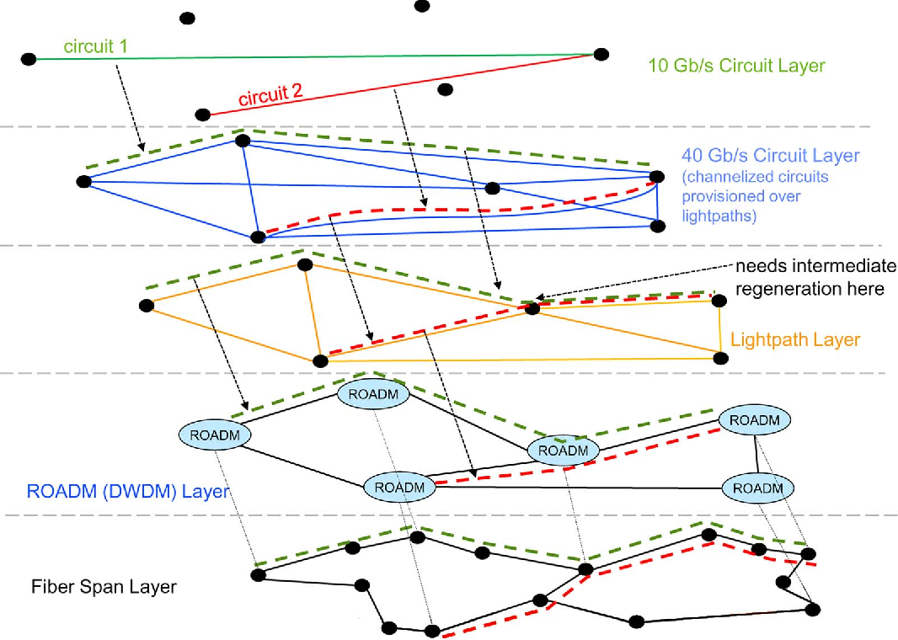

IV. MANAGEMENT AND CONTROL IN

TODAY’S OPTICAL LAYER

The ITU-T has established many domains for network management.   
  
said. We'll limit our discussion to configuration management's primary domains here (installing and uninstalling connection management (creating cross-connects to enable end-to-end connections or circuits), equipment, setting them up, and bringing them into or out of operation), and fault management (reporting and assessing outages and quality of signal). Performance management is equally important, although it primarily deals with packet networks. For the sake of simplicity, we will combine pertinent elements of optical performance management with fault management in this instance. Provisioning, which combines configuration management and connection management, was covered in the preceding section.

1. Legacy DWDM Systems: Clearly, early DWDM systems had limited or nonexistent control plane and network administration capabilities. Even though some hybrid systems had cards with electrical fabrics as well,Thus, the two main network management functionalities offered in early systems were configuration management and fault management. These systems rely almost entirely on SONET/SDH protocols from the client signals for failure management (alarms). Alarms for amplifier failures, which are mostly dependent on power loss (DB attenuation), are among the rare exceptions. Furthermore, because DWDM links were typically coupled with SONET rings or linear systems with inline protection, maintenance staff had the option to put the individual SONET rings or chains into protection mode and then apply test analyzers to the DWDM signal, rather than offering complex and automatic optical signal analysis features.Historical point-to-point DWDM systems were often installed with a defined protocol and basic text-based network administration interfaces. Bellcore's TL1 is one example [2]. An OSS's basic interface was made possible by TL1. The SONET/SDH standard describes performance monitoring and alarms related to fault management for client signals. On the other hand, internal communications interfaces for DWDM systems are typically offered across low rate sideband wavelengths, or channels. This channel is utilized to connect with the inline amplifiers in addition to facilitating communication between the NEs. The proprietary protocol is used over the internal communications channel.

B.ROADM: The whole vendor subnetwork is sometimes managed by a small number of EMSs—sometimes even just one—despite though the network is dispersed throughout numerous geographic regions. Despite the ROADMs' CLI, most carriers prefer to utilize the EMS to communicate with the ROADM due to its more advanced GUI and customized representation of the ROADM's settings and condition. Additionally, the EMS uses protocols like CMISE, SNMP [3], CORBA, or XML [36] to provide an interface to an OSS, which is commonly referred to as a northbound interface. It's also interesting to note that a lot of EMSs use TL1 for their internal protocols with their NEs since it makes it easier for carriers who need it to establish an external TL1 network management interface. The majority of ROADMs currently Internally, create subnetwork circuits using the OTN signal standard. The transponders' firmware or software is used to encapsulate various client signal types (such as Ethernet, Fiber Channel, SDH, SONET, and SDH) into the internal OTN signal speeds. These days, the capabilities of various ROADM EMSs varies greatly from one another. Certain EMSs have the ability to cross-connect and route a circuit between two designated transponder ports automatically. Here, the EMS selects the links and wavelength, gives the individual NEs instructions to cross-connect, keeps track of the circuit request's progress, and notifies the northbound interface when the circuit request is finished. Some EMSs only use one NE basis for operations.

Unlike networks at higher layers, the optical layer is more complicated by signal quality. For instance, adjusting the transponder laser, balancing the power in the amplifiers, and settling the signal further are necessary steps in establishing a new circuit. Additionally, as Figs. 3 and 4 demonstrate, optical reach is a significant problem, and occasionally interim regeneration is required to support a circuit. The majority of suppliers additionally provide a coordinated NMS since computing optical reach is an extremely challenging optical problem that depends on particular, proprietary vendor technology. The NMS performs two primary tasks: 1) support engineers in the engineering of constructing or expanding vendor ROADM subnetworks across current fibers and locations, and 2) replicate circuit pathways over a deployed vendor subnetwork while considering signal quality requirements. As the reader would have readily deduced, this means that the provisioner needs to speak with an NMS for each path segment that crosses a vendor subnetwork before approving a circuit request. Let's take an example where a carrier installs vendor-A DWDM equipment for long-haul (between big cities) and vendor-B DWDM equipment for regional transport (connecting smaller groups of metro areas).   
Because of this, many circuits with endpoints in smaller metro areas will still route through three segments, which correspond to vendor subnetworks A-B-A, even with just two vendors.   
After obtaining the path, wavelength, and regeneration data for every segment from the NMS, the provider submits the request into a provisioning and OSS. An order document, or form, is created by the OSS for each   
  
segment per segment equipment installation and cross-connect requirements. The way each cross connects   
  
then is determined by the step category that was specified in the preceding section: category 2) is routed to a workforce management company, category 3) is routed to a provisioning center whose staff issues commands to the EMS or CLI, and category 4) step is routed automatically to the relevant EMS's northbound interface.   
It should come as no surprise that provisioning a circuit in the optical layer can take a while these days. To enumerate the causes:

OSS. The OSS creates an order form (document) for every   
1) The NMS/EMS interface can be complicated; 2) There might not be a flow through from OSS to EMS (via the northbound interface); 3) A lot of the circuit order needs manual steps, like patch panels (manual cross connections) because of vendor subnetwork crossings or intermediate regeneration; 4) Even with fully or semiautomated automated cross connections (much faster than above), optical signal settling times can be lengthy in comparison to cross-connect speeds in higher layer networks.   
In Section V, we'll talk about some of the corporate background that gave rise to this development.

Last but not least, fault management is comparable to that of the point-to-point DWDM system with the exception that all more recent ROADM internally employ OTN encapsulation of the circuits; consequently, the alarms identify impacted slots and ports in terms of the models and alarm specifications for OTN termination-point information. For the client side of the optical transponder (e.g., SONET, SDH, Ethernet), different alarm specifications are employed.  
In Section V, we'll talk about some of the corporate background that gave rise to this development.

1. Integrated Interlayer Network Management:

We go over again the two main features of networks that were mentioned in the introduction: network stacking and restoration. These days, disruptions that start at lower layers are harder to diagnose and respond to because restoration is usually done at upper layer networks.   
For instance, a fiber cut or DWDM amplifier outage may occasionally impact ten or more IP-layer links, whereas an inter-mediate transponder failure may impact just one IP-layer link and be difficult to distinguish from a single router port outage. As a result, modeling the intricate relationships between the layers is necessary for the most efficient approach to network management.   
Traditionally, IP backbones have depended on IP-layer reconvergence techniques, often known as internal gateway protocols, like OSPF [20] or more overt restoration protocols like MPLS-TE [21] and MPLS fast reroute [22]. The IETF is the organization that created and standardized each of these protocols.

As a result, IP backbones were usually constructed with enough spare capacity to restore the network from the probable outage of an entire router, whether due to hardware/software failure or maintenance activities. This was done in order to achieve sufficient network availability. Therefore, without requiring a large amount of additional capacity beyond what is needed for the potential (single) router outages, the majority of fiber outages and other optical-layer problems can be restored. Effective capacity planning, however, necessitates a thorough understanding of the lower layer outage types and the routing of all IP lines via DWDM systems, fibers, etc. An industry-wide notion known as the SRLG is used to model these interactions. The next step in restoration capacity planning is a thorough study of all possible SRLG failures and the selection of suitable capacity allocations to achieve the intended aim for the availability of the network.   
The majority of sizable routers nowadays have the capacity to combine several physical links (interfaces) between neighboring routers into a single logical link, which the inner gateway protocol subsequently advertises as a single link.Along with   
  
IP routing protocols (like OSPFV) that do not consider link capacity but do mention a version that is capacity-sensitive   
  
termed OSPF-TE has been specified), losing a sizable portion of a link bundle's component links (but not all of them) would typically cause the traffic load on that link to be handled by the remaining capacity, which could cause severe congestion. How is this possible to occur?   
Due to the various layering, there's a chance that some of the bundle's links may break when the link bundle expands over time through the addition of new links. Recently, router technology has   
ogies have been modified to deal with these situations, terminating the residual capacity in the case that the link capacity falls below a predetermined level. But it can be challenging to figure out what that threshold should be for every scenario of failure and then make sure there is enough capacity elsewhere in the network.   
Whether an optical amplifier fails, a fiber cut occurs, or the router at the remote end of the link has a port outage, routers are capable of detecting outages that occur anywhere on a link.   
Although the router is unable to discriminate between them, it will reroute traffic appropriately and produce traps to alert operations staff. However, completely different work groups or even an external carrier (such as) are usually in charge of managing the IP and optical layers. (Lease Private Line, for example). The optical maintenance work groups would also receive alert notifications in the case of an optical-layer failure. Consequently, there may be a great deal of duplication of troubleshooting labor between the two work groups if there aren't sophisticated alert correlation methods between the events from the two different tiers.Effective correlation between the alarms produced by the two distinct layers can guarantee that both work groups receive timely notifications about the matter,

D. Metro Segment: Metro networks have a substantially lower geographic diameter than the core section. Additionally, a lot of carriers in a certain metro region utilize the same DWDM provider.   
  
Therefore, intermediate regeneration and intervendor (domain) routing are frequently not problems. However, in contrast to the core segment, ROADMs are often only deployed in a subset of a major metro's COs.   
Therefore, a circuit path may consist of lengthy patches panel cross connect sequences in COs, followed by intricate access provisioning on distribution/feeder fiber. The business case for more autonomous connection management in metro areas' optical layers has diminished as a result of these obstacles. For instance, if a circuit needs one piece of automated cross connections and fifteen human cross connects via direct fiber Metro networks have a substantially lower geographic diameter than the core section. Additionally, a lot of carriers in a certain metro region utilize the same DWDM provider.   
Because the overall cost is not greatly impacted by intervenor (domain) routing and intermediate regeneration connections using ROADMs, it is difficult to demonstrate the business case for the ROADM section. We are unable to get into more intricate metro difficulties due to length restrictions.

V. FUTURE EVOLUTION OF THE OPTICAL LAYER:

Now that we have a clear picture of the optical layer's current surroundings in the core network segment, we can talk about possible future directions for network management and control. To paraphrase the introduction, a large carrier's decision is based on its unique requirements and there is a wide range of network management protocols available. We will give a broad overview, highlight the key findings from the earlier parts, and provide business insights in order to avoid delving into a detailed discussion of the various management protocols and their intricacies.

1. Network Control and Management Gap:

We provide an overview of the following findings on the optical layer in the carrier environment of today.   
1) Due to optical reach constraints, the optical layer may need to do numerous manual steps in order to furnish a circuit, including NMS/EMS circuit design coordination, crossing vendor subnetworks, and intermediate regeneration.   
2) Compared to their higher layer counterparts, even the completely automated components of providing an optical-layer circuit operate much more slowly.   
3) The primary driving force behind the evolution of the optical layer has been the desire to lower interface prices for higher layer switches. This has led to a straightforward goal of raising Brate and reach.[4) Higher network levels are used to offer restoration; as a result, network management, planning, and Restoration needs to operate on all the layers more cohesively.   
5) No extensive dynamic services that call for quick connection management at the optical layer have been implemented.

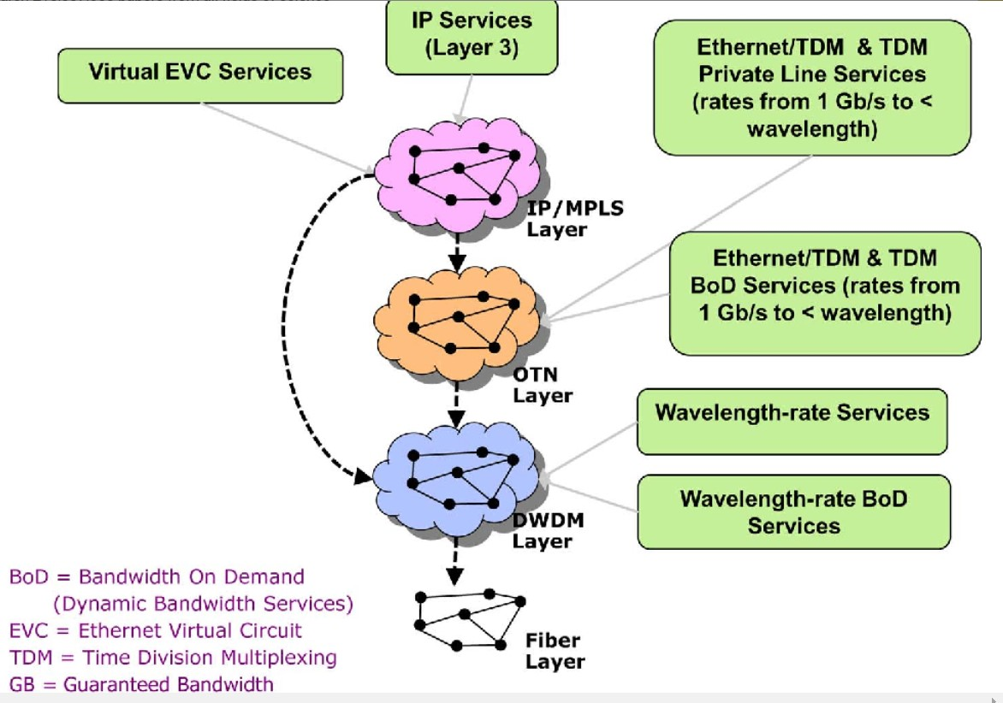

In light of observations 3–5, it has proven difficult to make a case for the advancement of optical layer technology and network management capabilities to allow for even quicker (flow routing) via MPLS tunnels in routers, or provisioning speeds comparable to those of DCS levels. In fact, taking another look at Fig. 2, we see that the optical layer is essentially a slave to the other internal upper layers, most notably the IP layer, which has historically been the layer that is growing the fastest. The exception to this is the very highest rate private line services, which only use a small portion of the optical-layer capacity. So, rather than being similar to phone calls or online access requests, demand for the optical layer (from links of higher layer networks) is caused by a slower network design.

Because of all these observations, a void has developed. between the dynamic and autonomous character of today's optical layer networks and their administration and operations among its networks at higher layers. Many in the industry have overlooked this gap or believed it will close quickly up until now, but it has continued for more than ten years. This continues because, as we've shown, business viewpoints also have an impact on the evolution of the optical layer, in addition to technological advancements. For instance, if, in contrast to observation 5, carriers had demonstrated in their internal business cases that there was a demand for a high-volume, speedy, and dynamic optical-layer connection service, this gap would have been closed considerably faster.

1. Technology Evolution of the Optical Layer:

Over the last 15 years, there has been a significant technological progress in optical and WDM transmission technologies.   
As mentioned earlier, the early versions of DWDM technology had restricted point-to-point networking, low data rates, and a few number of wavelengths. ROADM systems with 100 Gb/s rates, 80 wavelengths, and lightpaths with 1000–1500 km reach are now being implemented. Technologies like coherent detection, which uses very high rate signal processing to permit more complex detection of distinct optical pulses, and multiple variants of QPSK, which modify the properties of the optical pulse to enable a broader range of symbols, have made this possible. In addition to increasing speed and range, coherence detection eliminates a number of cumbersome or costly techniques for getting around optical limitations like PMD, allowing transfer across a larger range of fiber types. Examining [16], we discover that intercity IP traffic is no longer growing as rapidly as it formerly did. Furthermore, for higher rate packet-switch interfaces, the economy of scale is flattening. As a result, the main forces behind increased Brate[wavelengths won't be as strong as they were previously. On packet switches, the top-rate interface has gradually improved over time, reaching speeds of 155 Mbps, 622 Mbps, 2.5 GB, 10 GB, 40 GB, and 100 GB. The channel rates for DWDM have matched. The long-term result is that, as we increased the reach at a particular wavelength rate, the demand for the next higher router interface rate increased, and as a result, the corresponding optical reach shrank. This implies that the demand for intermediate regeneration should ultimately lessen as the craze for higher maximum rates fades.   
We see that an additional consequence of the more recent coherence detection technologies is an increase in lightpath settling durations, which adds to the network management gap. Here's another illustration of how the present network management and control environment is shaped by business context: Specifically, it was decided that lowering interface costs (both IP layer and optical layer) was more important than shortening provisioning times.

1. Advent of the OTN Layer:

OTN technology has arisen as a result of SONET and SDH running out of gas [17]. In order to standardize forward error correction (FEC) and overhead channels in optical networks, the OTN protocol stack was first developed. This significant technological development made it possible for the previously stated rate and reach to evolve. From that point on, it has developed into a multiplexing hierarchy, a DWDM internal transport protocol, and an encapsulation/container mechanism for various signal formats.   
Thus, the OTN switch is a type of DCS that has recently emerged to cross link lower rate channels among higher rate interfaces, much as DCSs evolved to automatically cross connect lower rate channels among higher rate SONET or SDH interfaces. But now a new business query has surfaced: Why close the gap between optical-layer management and control if OTN switches offer all of the network management features (and more) of their earlier DCS counterparts?Potential future core architecture is shown in Fig. 5. In this architecture, reduced frequency In the IP/MPLS layer, private line services have moved to EVC services. Services on a private line route over the OTN layer, whose lowest signal rate is 1.2 Gb/s, at 1 Gb/s or higher. The fastest private line service crosses the ROADM layer straight away. It should be noted that the IP layer links can route either straight onto the DWDM layer or over the OTN layer. More on this option is covered in the section that follows.

1. Advanced Network Management and Control Capabilities:

What is the purpose of bridging if OTN switches offer all of the network management features (and more) of their former DCS counterparts?We categorize private line traffic into two groups, traditional and BoD, as shown in Fig. 5. As we mentioned in observation 5) in Section V-A, few carriers have implemented full-fledged services for DCS layers, let alone the optical layer, despite the fact that BoD has been a popular subject and topic of publishing for years. For instance, from the first proof, the authors of this work pioneered AT&T's OMS. concept (around the early 2000s) until the service's 2005 introduction. At the time, it was among the first genuinely long-distance, high-rate BoD services. Refer to [9] and [30].   
Nevertheless, we observe that even while OMS utilizes the term "Boptical," it is actually given by the IOS layer, in accordance with the stricter criteria of this work. The IOS layer is an intelligent broadband DCS layer, as was previously mentioned. Relevantly speaking, nevertheless, OMS was made possible by the IOS layer's advanced network management and control features.   
A client can create on-demand circuits between any of his interfaces at the core CO once his customer premise equipment is connected to the IOS via the access/metro segments (a Bpipe[).of different places, within the pipe's capacity. Moreover, the IOS layer offers additional channels for restoration; as a result, the additional capacity required for BoD demand can share the channels for restoration, which is essential to the business case's success. Evidently, in light of the earlier account of today's BoD extension to the optical layer is more difficult from a technological and financial standpoint.   
We are unable to cover all of the papers that deal with optical-layer BoD, however we can mention that CORONET [7] is a DARPA-sponsored project that attempts to solve this issue. The main objectives of CORONET are to create a dynamic core optical layer with a highly dispersed control plane that allows circuits to be provisioned quickly. Phase I of CORONET addressed network design, protocols, and architecture [5], [6] Although the OTN switch was not specified at the outset of Phase I, CORONET Phase II is currently in progress and will address the OTN layer's function as well as the realistic commercial implementation of these objectives at the time this document is written. Realistic cost analyses of various architectural options for the relationships between the layers in Figure 5 are among the activities.

1. Methods for Fully Automated Provisioning:

Setting aside the business case justification for the time being, we note that the manual provisioning steps previously mentioned must be overcome if we are to advance the state of the art in optical-layer network management and control to levels comparable to those of its higher-layer networks. In order to do this, we now outline a series of technologies and tools that are being developed throughout the R&D stage. Fiber connectivity is included in the two manual processes [category 1) and 2) in Section III-C that take the longest. These actions are the result of three main factors: 1) connecting vendor subnetworks' circuits; 2) wiring client equipment (via the metro/access segment) to the end transponders; and 3) intermediate regeneration. There are two main concepts for automating these steps: using the transponder pooling and previously mentioned FXC. Instead of establishing and fibering shareable pools of transponders, most carriers now install and link transponders per individual circuit order in order to reduce costs. For optimization algorithms for, refer to [12] and [4].   
calculating and arranging transponder pools. These two ideas are fundamental to the CORONET project. [32]. In addition to the initial provisioning of services, fast restoration requires the ability to switch a circuit (via the FXC) to a spare transponder. This is necessary for two reasons: first, to provision a circuit over an alternative restoration path that crosses multiple lightpaths, and second, to perform Bitless rerouting (normalization) of a circuit path following outage repair [35]. The interactions between the NMS and EMS and the provisioning/planning staff make up the second longest category of manual steps. In order to guarantee that there is sufficient spare channel capacity and that signal quality is provided, the primary goal of the NMS is to theoretically route (also known as Bdesign[) a circuit over a path of light-paths (including the selection of spare wavelengths) and intermediate transponders (if necessary). Multiple vendor subnetworks, as previously mentioned, significantly increase provisioning process delays. The authors and their associates have devised and executed a procedure within AT&T's network to mechanize the NMS segment of the provisioning phase. Requesting that each vendor NMS precalculate a reachability matrix that identifies the pairs of ROADMs is the main premise behind this method. which lightpaths can be created between (i.e., where no intermediary regeneration is required), and then construct an advanced optical-layer routing tool for the entire network. The tool creates a graph of logical edges representing possible lightpath creation locations in each vendor subnetwork using the reachability matrix. To simulate the cost and the possibility of vendor subnetworks being connected via transponders, more edges are added to the graph. After that, circuits are routed over this enhanced graph to meet fiber-layer diversity goals or minimize costs. A tool like this is explained in [26]. Following the automation of the NMS contacts, we then need to focus on the provider's manual interactions with the EMSs. This therefore raises the query which control plane protocol is used for use for the ROADMs and EMS. This issue is discussed in the next section.

1. Potential Impacts of Standards Organizations:

The three categories that make up standards and their subsets who have the greatest impact on DWDM and optical-layer network management and control are the ITU, the IETF, and the OIF. We provide a quick overview of their work in relation to the optical layer. Nonetheless, a significant portion of these organizations' efforts are focused on the DCS levels; to reiterate our previous definition, the Boptical layer in this research refers only to DWDM apparatus and the fiber network that supports it.   
Consequently, despite the fact that the majority of significant DWDM equipment manufacturers participate in and contribute to these standards organizations, there is still a significant gap between the standards and the adoption of DWDM equipment in carrier networks, particularly for connection management, for the reasons previously mentioned. Specifically noteworthy is ITU Study Group 15. This is due to the fact that, as previously mentioned, OTN is used by the majority of recently installed DWDM equipment for its internal signal formatting, multiplexing hierarchy, FEC, and other data communications. Refer to G.709 and G.798 ITU specifications [17]. As a result, the majority of optical vendors include ITU defect management elements and requirements in their internal MIB and equipment models. The EMS sends notifications and alarms to the northbound interface, which is how these items primarily show up. The connection management control plane approaches for the optical layer that stand out the most are GMPLS [1], [8], which were developed by the IETF CCAMP working group [24].   
Nevertheless, the initial GMPLS signaling protocols did not fully address all of the significant problems that had previously been discovered (such as manual cross connection, optical reachability restrictions, and intervendor subnetworks). For instance, the IETF PCE [23] addresses reachability and optical routing concerns. Furthermore, there are numerous research initiatives and suggestions that deal with how to model impairments and take into account their influence on reachability limits in routing through standards bodies. For illustration, refer to [27]. The OIF uses the E-NNI protocol to handle interdomain subnetwork communication [29].   
Some cutting-edge suggestions for making use of the newly available The EO-NET project is investigating possibilities for nondirectional, colorless (tunable) transponders and beyond, such dynamically varying the wavelength/channel spacing and rate [12].

We briefly address PCE since it might be a good fit for the challenging routing and provisioning issues outlined above, even if it is outside the scope of this study to address all relevant standards, concepts, and proposals in the literature. According to the IETF (RFC 4655 [22]), a PCE is any entity (component, application, or network node) that has the ability to compute a network path or route by using computational constraints and a network graph.[For instance, a PCE could interact with distributed, inter-NE provisioning protocols, compute complex capacity-sensitive wavelength assignment optimization, store and update reachability information associated with each subnetwork, and communicate with various vendor subnetworks (or domains). For instance, routing (OSPF-TE) and signaling (RSVP-TE) are included in GMPLS. PCE with relation to the Different paradigms, including GMPLS-based signaling, PCE-based signaling, and hybrids of the two, will be supported by the optical layer.Another incredibly intricate requirement that we demonstrated One potential use for PCE in Fig. 4 is the capability to route groups of connections in a diversified way. missions that call for an offline, graph-based knowledge base on fiber-layer routes (that is, an SRLG database with information about upper layer linkages that cross it). A major carrier's core network needs to have all of these features, plus more. There are currently no big carrier networks that have adopted standardized PCE implementations. But AT&T has put in place a planners employ on a regular basis to route circuits (connections) via the DWDM layer is a planning system that combines all of the previously described features [26]. In order to integrate with possible standardized control planes of next-generation ROADMs with non-rectional, colorless (tunable), and (potentially) FXC-like capabilities, AT&T is investigating the viability of extending this feature to a PCE implementation.

1. Business Case for Optical-Layer Evolution:

After more than ten years of technological innovation, optical management and control have advanced more slowly than optical layer capacity, connectivity, cost savings, and signal quality. As demonstrated by our work with cutting-edge network topologies and protocols, this is definitely not the result of a lack of research and development. The creation of a business case that satisfies the financial requirements demanded by the finance and network planning departments of major telecommunications carriers is the next stage in this progression. Ideas like FXCs, transponder pooling, faster circuit tuning/settling, improved routing tools, and optical-layer restoration would probably need to produce cost savings and/or revenue opportunities in order to be widely adopted, given the numerous demands on resources in a large telecommunications carrier. The authors believe that most of these advances will eventually be put into practice due to three factors: 1) the continued decline in transponder costs and prices; 2) the leveling off of growth in core IP traffic (and thus the lack of historically frenzied need for wavelength rate increase); and 3) advancements in DWDM technologies.   
The pace of this implementation, however, will be a crucial factor that depends on the viability of the business cases.

**Conclusion:**

To satisfy the needs of modern digital services, telecommunications companies need to effectively oversee and manage their optical networks. OptiTel successfully handled the issues of dynamic traffic patterns, resource allocation, fault management, scalability, and cost optimization by implementing cutting-edge solutions including SDN, machine learning, and NFV. The outcomes show how modern optical network control and management systems may revolutionize the way that resources are used, services are delivered, and operations are conducted.

Reference:

[1] P. Ashwood-Smith, Y. Fan, A. Banerjee, J. Drake, J. Lang, L. Berger, G. Bernstein, K. Kompella, E. Mannie, B. Rajagopalan, D. Saha, Z. Tang, Y. Rekhter, and V. Sharma,Generalized MPLSVSignaling Functional Description, IETF Internet draft, Jun. 2000.

[2] Bellcore, Operations Application MessagesVLanguage for Operations Application Messages, TR-NWT-000831. [Online]. Available: http://telecom-info. telcordia.com/.

[3] U. Black, Network Management Standards SNMP, CMIP, TMN, MIBs, and Object Libraries, A. Bittner, Ed. New York: McGraw-Hill, 1995, ISBN: 007005570X.

[4] S. Chen, I. Ljubic, and S. Raghavan, BThe regenerator location problem,[ Networks., vol. 55, no. 3, 2010, pp. 205–220.

[5] A. Chiu, G. Choudhury, G. Clapp, R. Doverspike, J. W. Gannett, J. G. Klincewicz, G. Li, R. A. Skoog, J. Strand, A. Von Lehmen, and D. Xu, BNetwork design and architectures for highly dynamic next-generation IP-over-optical long distance networks,[

J. Lightw. Technol., vol. 27, no. 12, pp. 1878–1890, Jun. 2009.

[6] A. Chiu, A. G. Choudhury, G. Clapp, R. Doverspike, M. Feuer, J. W. Gannett, J. Jackel, G. T. Kim, J. G. Klincewicz, T. J. Kwon, G. Li, P. Magill, J. M. Simmons, R. A. Skoog, J. Strand, A. Von Lehmen, B. J. Wilson, S. L. Woodward, and D. Xu, BArchitectures and protocols for

capacity-efficient, highly-dynamic and highly-resilient core networks,[ J. Opt. Commun.Netw., vol. 4, no. 1, pp. 1–14, Jan. 2012.

[7] DARPA CORONET Project. [Online]. Available: http://www.darpa.mil/Our_Work/STO/

Programs/Dynamic_Multi-Terabit_Core_ Optical_Networks_(CORONET).aspx.

[8] R. Doverspike and J. Yates, BChallenges for MPLS in optical network restoration,[ IEEE Commun. Mag., vol. 39, no. 2, pp. 89–97, Feb. 2001.

[9] R. Doverspike and J. Yates, BPractical aspects of bandwidth-on-demand in optical networks Panel on Emerging Networks Service Provider Summit, Anaheim, CA,

Mar. 2007.

[10] R. Doverspike and P. Magill, BChapter 13 in Optical Fiber Telecommunications V B,[ in

Commercial Optical Networks, Overlay Networks and Services. Amsterdam, The Netherlands:

Elsevier, 2008.

[11] R. Doverspike, K. K. Ramakrishnan, and C. Chase, BChapter 2 in Guide to Reliable

Internet Services and Applications,[ in Structural Overview of Commercial Long Distance IP Networks, C. Kalmanek, S. Misra, and R. Yang, Eds. 1st ed. New York: Springer-Verlag, 2010.

[12] EO-NET, Project on Elastic Optical Networks. [Online]. Available: http://www.celtic-

initiative.org/Projects/Celtic-projects/Call7/ EO-Net/eonet-default.asp.

[13] C. V. Saradhi, R. Fedrizzi, A. Zanardi, E. Salvadori, G. M. Galimberti, A. Tanzi, G. Martinelli, and O. Gerstel, BTraffic independent heuristics for regenerator site selection for providing any-to-any optical connectivity,[ in Proc. Conf. Opt. Fiber Commun./Nat. Fiber Opt.

Eng. Conf., Los Angeles, CA, Mar. 2010, pp. 1–3.

[14] M. D. Feuer, D. C. Kilper, and S. L. Woodward, BChapter 8 in Optical Fiber Telecommunications V B,[ in ROADMs and Their System Applications. Amsterdam, The Netherlands: Elsevier, 2008.

[15] C. Fludger, T. Duthel, D. van den Borne, C. Schulien, E.-D. Schmidt, T. Wuth, J. Geyer, E. De Man, G.-D. Khoe, and H. de Waardt, BCoherent equalization

and POLMUX-RZ-DQPSK for robust 100-GE transmission,[ J. Lightw. Technol.,

vol. 26, no. 1, pp. 64–72, Jan. 2008.